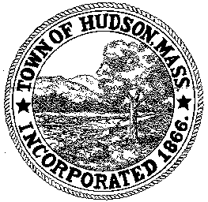

CONSERVATION COMMISSION
78 Main Street, Hudson, MA 01749
(978) 568-2020

Paul Byrne, Chairman W. Minot Wood, Vice Chairman David Esteves, Member

Terrence Joyce, Member Leif Longtine, Member Joseph Rodrigues, Member Al Tashian, Member

Agenda
March 4, 2010 7:00 P.M.

- Preliminaries
  - Open Meeting
  - Roll Call
1.3 Additions or Deletions to the agenda

2.0 Hearings and Appointments
2.1 RDA 389
Applicant: Jane Morgan
Location: 36 Plant Avenue
The removal of a tree which is in danger of falling

2.2 RDA 390
Applicant: Mike Shutt
Location: 41 Rolling Lane
Installation of a pool which will be 85’ from the wetlands

2.3 DEP 190-512
Applicant: Neil Fossile
Location: 37 Lake Shore Drive
Seeking an amendment to the Order of Conditions for the installation of a fence within the wetlands.

3.0 General Business
3.1 Questions and Comments from the Public
3.2 Voucher ConCom 030410 $30.92
3.3 Request for Review and Comments:
Sauta Cornfield Soccer Field Project

4.0 Adjournment

Next Meeting March 18, 2010

